1) Assumptions in individual preference and their importance.
1. The Axiom of Completeness:
Prima facie, we assume that any two bundles can be compared. For example, given the above two bundles, viz., the X-bundle and the Y-bundle we assume that (x₁, x₂) > (y₁, y₂) or (y₁, y₂) > (x₁, x₂) or both. This means that the consumer cannot choose between the two bundles, i.e., he is indifferent between them.
All commodity bundles can be compared in terms of either indifference or preference. This axiom is also referred to as the axiom of comparability or connectedness. This axiom (assumption) says in effect that the consumer is able to express a preference or indifference between any pair of consumption bundles however alike or unalike they may be. This ensures that there are no ‘holes’ in the preference ordering, points or areas to which it does not apply.
2. Axiom of Reflexiveness (reflexivity):
Any bundle is assumed to be as good as it. This means that (x₁, x₂) > (x₁, x₂). In other words, any bundle is preferred or indifferent to itself. This ensures that every bundle belongs to at least one indifference set, namely, that containing itself, if nothing else.
3. Axiom of Transitivity:
If (x₁, x₂) > (y₁, y₂) and (y₁, y₂) > (z₁, z₂) then it is assumed that (x₁, x₂) > (z₁, z₂). Alternatively stated, if X = (x₁, x₂) is at least as good as Y = (y₁, y₂) and that Y is as good as Z = (z₁, z₂), then x must be at least as preferable as Z = (z₁, z₂).
Both indifference and preference must be transitive. If any bundle X is strictly preferred to Y and F is strictly preferred to Z, then X must be strictly preferred to Z. Similarly, if the consumer is indifferent between X and Y and between Y and Z, he will indifferent between X and Z. Thus if X > Y and Y > Z, if X is weakly preferred to Y and Y is weakly preferred to Z, then X will be weakly preferred to Z.

2) A) E (u (W) =0.5In (4000) +0.5In (6000)
=0.5(8.29415) +0.5(8.699515)
=8.4967825
e^{Inw} =w=e^{8.496782}=$4898.89

So the individual would be identified between the gamble and $489898 for sure. This amount to a risk premium of $101.02 therefore he could not by insurance for $125.

B) The second gamble given his first loss is $4000 plus or minus $1000 expected utility
E [u (w)] =0.5In (3000) +0.5In (5000)
=0.5(8.006368) +0.5(8.517193)
=8.26178
e^{Inw}=e^{8.26178} =$31872.98=w
Now the individual would be willing to pay up to $127.02 for insurance since insurance cost only $125 he will buy it.

3)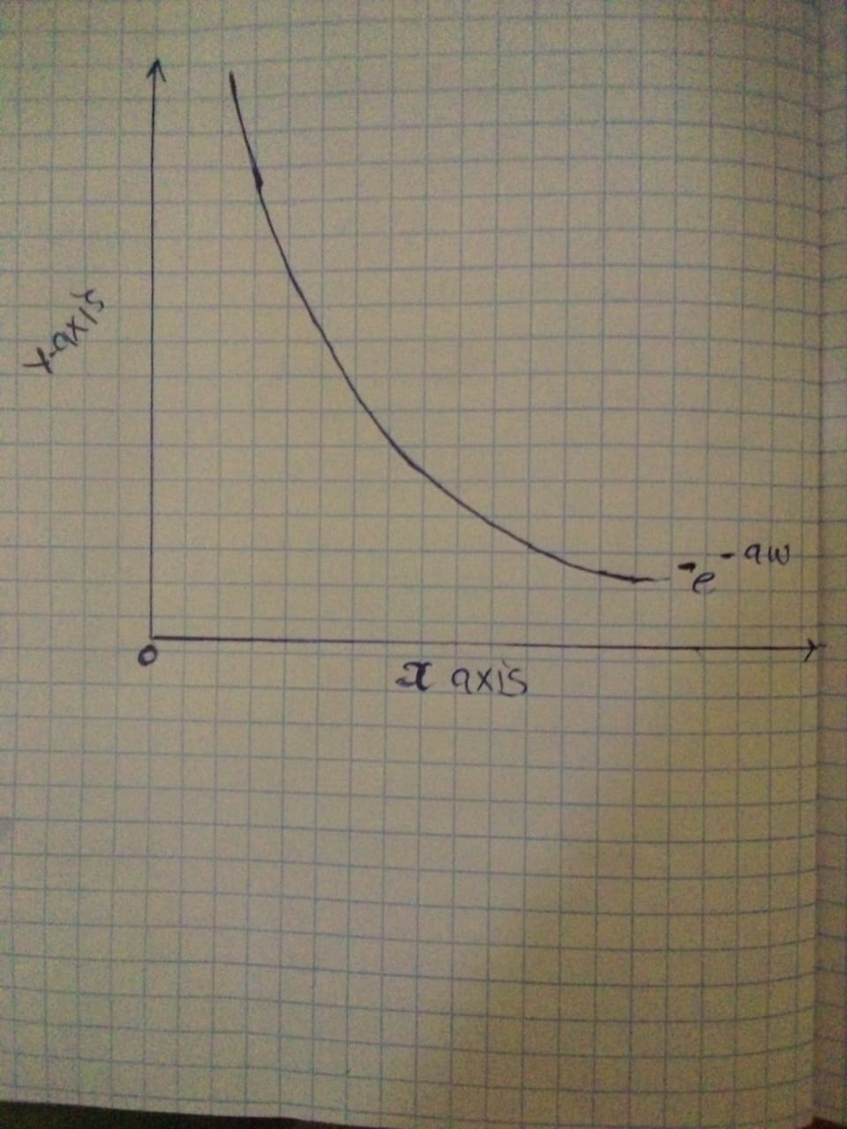
B) U (w) =-e^{-aw} where a is greater than zero
Marginal utility =mu =dy/dw = -e^{aw} a is greater than 0
The function exhibits negative marginal utility
Risk aversion = A(w)= -u’(w)/u’(w)
U’ (w) = mv = -ae^{aw}.a=-ae^{w}
A (w) = - (-a²e^{aw})/-ae^{aw}=-a
It therefore exhibits negative risk aversion.

c) A’ (W) =d [A (w)]/dw=0

The function does not have decreasing absolute risk aversion as for that a%w) >0

d) The function does not have constant absolute risk aversion as N’(w) =0

4) Let the three states be denoted by 1, 2 and 3 respectively.
Hence, p1 = 10%; p2 = 10%; p3 = 80%; W1 = 1; W2 = 50,000; W3 = 100,000
(a)The business owner's expected wealth = p1 x W1 + p2 x W2 + p3 x W3 = 10% x 1 + 10% x 50,000 + 80% x 100,000 = $ 85,000.10

(b)Utility of expected wealth = U [E (W)] = ln [E (W)] = ln (85,000.10) = 11.35

(c)E (W1) = ln (W1) = ln(1) = 0
E (W2) = ln (W2) = ln (50,000) = 10.82
E (W3) = ln (W3) = ln (100,000) = 11.51
Hence, the expected utility of wealth = p1 x E (W1) + p2 x E (W2) + p3 x E (W3) = 10% x 0 + 10% x 10.82 + 80% x 11.51 = 10.29

(d)Since, the utility of expected wealth U [E (W)] = 11.35 > the expected utility of wealth = 10.29; this person is indeed risk averse.
(e)What Is the Certainty Equivalent?
The certainty equivalent is a guaranteed return that someone would accept now, rather than taking a chance on a higher, but uncertain, return in the future. Put another way, the certainty equivalent is the guaranteed amount of cash that a person would consider as having the same amount of desirability as a risky asset.
What Does the Certainty Equivalent Tell You?
Investments must pay a risk premium to compensate investors for the possibility that they may not get their money back and the higher the risk, the higher premium an investor expects over the average return. If an investor has a choice between a U.S. government bond paying 3% interest and a corporate bond paying 8% interest and he chooses the government bond, the payoff differential is the certainty equivalent. The corporation would need to offer this particular investor a potential return of more than 8% on its bonds to convince him to buy.
(f)The risk premium of a gamble is the extra amount required to make an agent indifferent between the gamble and the expected value of the gamble. Conversely, it can also be thought of as the amount of money a risk averse agent will pay to avoid any risk. For example, the expected value of the gamble is $15. The utility received from the expected value of the gamble is 1.17 (log 15). The expected utility from the gamble is 1.15 (½ log 10 + ½ log 20). It is equal to the utility received when consumption is $14.
Therefore, the risk premium is $15 – $14 = $1. A risk averse agent is indifferent between a gamble that offers an expected value of $15 and receiving $14 with certainty. The consumer would pay up to $1 to avoid taking the gamble.
(g)One should pay premium for health insurance according to the pocket so that wealth is not affected. And starting premiums early age also helps you give early premiums and save money

